Lab Tasks
Marks : 10, All Questions carry equal marks

Exercise 1 (JAVA Environment Installation & Error Messages)
Set up a Java development environment. In the main() method of your program try to compile the following invalid Java code snippets. Record the error messages you receive. What do you think each error message indicates?

System.out.printn(“Hello World”)
Error message indicates: it indicate the printn is not contain in prinstream class and semi comaa ‘;’ is not given
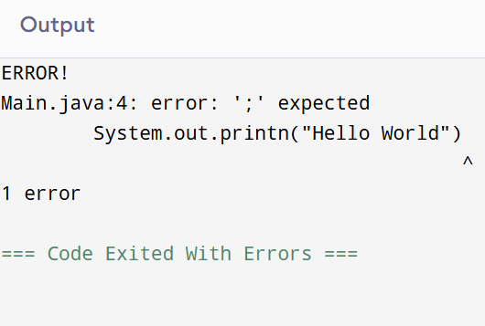

System.out.printn(Hello World)
Error message indicates: it indicate the printn is not contain in prinstream class and semi comaa and inverted comma “” is not given

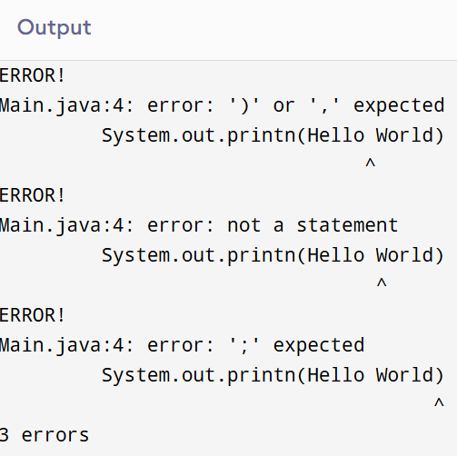

System.out.println”Hello World”;
Error message indicates: it indicate the you do not close string () it does not cntain in printstream
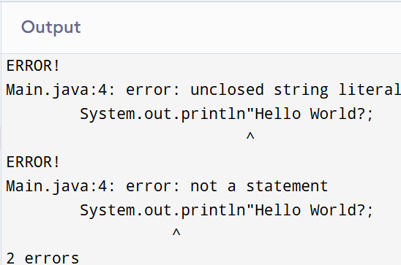

println(“Hello World);

Error message indicates: it indicate the you do not close literal string ()
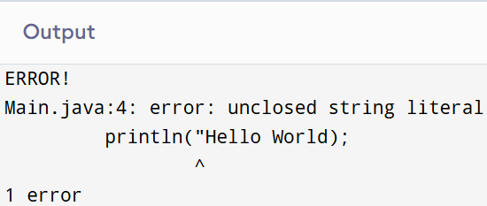
To generate one final error message, remove one of the brackets from the end of your program. Now what message do you receive?

Exercise 2 (Mathematical Expressions)
Write Java code to identify if the given input by the user is even or odd.
import java.util.Scanner;
class Main {
public static void main(String[] args) {
Scanner input=new Scanner (System.in);
System.out.print("Enter the number: ");
int a=input.nextInt();
if(a%2==0){
System.out.println("Even");
}
else{
System.out.println("Odd");
}
}
}
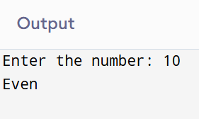

Exercise 3 (Type casting)
Perform division using two double variables and store the result in int variable and print the results
import java.util.Scanner;
class Main {
public static void main(String[] args) {
Scanner input=new Scanner (System.in);
System.out.print("Enter the number 1: ");
double a=input.nextDouble();
System.out.print("Enter the number 2: ");
double b=input.nextDouble();
int division=(int)a/(int)b;
System.out.println("Division of two numbers are: " +division);

}
}
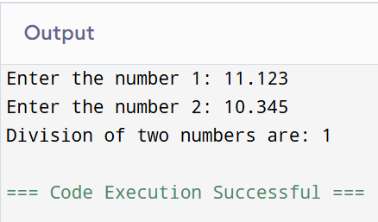

Exercise 4 (Operators)
Find largest among three numbers using if..else as well as operators statement

Enter value a:30

Enter value b:10

Enter value c:70
import java.util.Scanner;
class Main {
public static void main(String[] args) {
Scanner input=new Scanner (System.in);
System.out.print("Enter the value of a: ");
int a=input.nextInt();
System.out.print("Enter the value of b: ");
int b=input.nextInt();
System.out.print("Enter the value of c: ");
int c=input.nextInt();
if(a>b&& a>c){
System.out.println("a is largest");
}
if(b>a&& b>c){
System.out.println("b is largest");
}
if(c>b&& c>a){
System.out.println("c is largest");
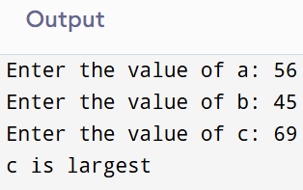
}

}
}

Exercise 5 (if/else, Array)

Create an array of 5 integers, input array elements and perform following tasks:
- Find and print largest number
import java.util.Scanner;
class Main {
public static void main(String[] args) {
Scanner input=new Scanner(System.in);
System.out.print("Enter the numbers: ");
int arr[]=new int[5];
for(int i=0; i<5; i++){
arr[i]=input.nextInt();
}
int largestNumber=arr[0];
for(int i=0; i<5; i++){
if(arr[i]>largestNumber){
largestNumber=arr[i];
System.out.println(arr[i]);
}
}
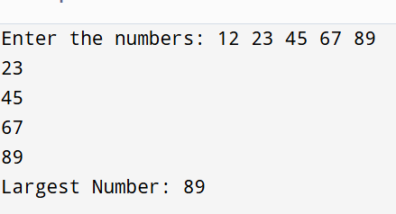
System.out.println("Largest Number: " +largestNumber);
}
}

- Input a number to search and print whether number is found or not
import java.util.Scanner;
class Main {
public static void main(String[] args) {
Scanner input=new Scanner(System.in);
System.out.print("Enter the numbers: ");
int arr[]=new int[5];
for(int i=0; i<5; i++){
arr[i]=input.nextInt();
}
System.out.print("Enter the search number: ");
int search=input.nextInt();
for(int i=0; i<5; i++){
int index=0;
if(arr[i]==search){
index=i;
System.out.println(+search+" number found at " +index);
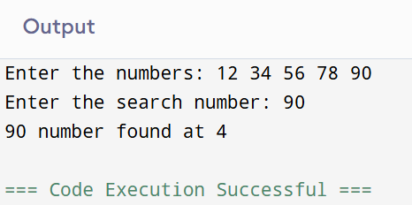
}
}
}
}

- Count how many even numbers are in it
import java.util.Scanner;
class Main {
public static void main(String[] args) {
Scanner input=new Scanner(System.in);
System.out.print("Enter the numbers: ");
int arr[]=new int[5];
for(int i=0; i<5; i++){
arr[i]=input.nextInt();
}
int count=0;
for(int i=0; i<5; i++){
if(arr[i]%2==0){
count++;
}
}
System.out.println(+count+ " times are come even");
}
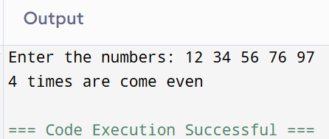
}

- Print elements in reverse order

import java.util.Scanner;
class Main {
public static void main(String[] args) {
Scanner input=new Scanner(System.in);
System.out.print("Enter the numbers: ");
int arr[]=new int[5];
for(int i=0; i<5; i++){
arr[i]=input.nextInt();
}
System.out.print("Reverse numbers are: ");
for(int i=4; i>=0; i--){

System.out.print(+arr[i]+ " ");
}
}
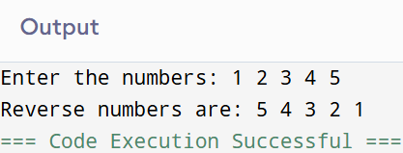
}

Exercise 6 (Debugging Practice)
Run the code, find/name the error, write in your own words (1-2 lines max) in 2nd column and solve it in 3rd column with minimal changes in it.
Code | Error/Analysis | Fix
int[] arr = new int[5];  for (int i = 0; i <= 5; i++) {  arr[i] = i * 10;  } | Array size is 5 so in loop it start with 0 so it end with 4 it means less then 5 | int[] arr = new int[5];  for (int i = 0; i < 5; i++) {  arr[i] = i * 10;}
int[] arr;  arr[0] = 10; | Int this code arr does not include in new memory and it does not fix size so how we initialize number | int arr[]=new int[5];  arr[0] = 10;
class InputTest {  public static void main(String[] args) {  Scanner sc = new Scanner(System.in);  int x = sc.nextInt();  }  } | In this code user input class is not import so how you take user input | import java.util.Scanner; class InputTest {  public static void main(String[] args) {Scanner sc = new Scanner(System.in);  int x = sc.nextInt();  }  }
for (int i = 0; i < 5; i--) {  System.out.println(i);  } | In loop decreament is use but according to condition is say that increament use | for (int i = 0; i < 5; i++) {  System.out.println(i);  }
int[] arr = new int[3];  System.out.println(arr[0]); | it means java automatically assign numbers so you did not assign arr[0] | int[] arr = new int[3]; for (int i = 0; i < arr.length; i++) { System.out.println(arr[i]);}
int x = 5;  if (x = 5) {  System.out.println("Equal");  } | In this you intilize x with 5 in if else compare the values so how you compare without true or false | int x = 5;  if (x = 6) {  System.out.println("Equal");  }
Scanner sc = new Scanner(System.in);  int n = sc.nextInt();  int[] arr = new int[n];  arr[n] = 10; | here is assign size with n so it start and the end less then n so how user at arr[n]=10 it is wrong | Scanner sc = new Scanner(System.in);  int n = sc.nextInt();  int[] arr = new int[n];  arr[n-1] = 10;

Post lab questions to ponder
- Can you cast string into int?
Yes
public class Conversion {
public static void main(String[] args) {
String str="123";
int num=Integer.parseInt(str);

System.out.println("Number is: " + num);
}
}

- Why JAVA when there are other OOP languages?
Java is popular because it is platform-independent secure, object-oriented and widely used in enterprise and Android applications

